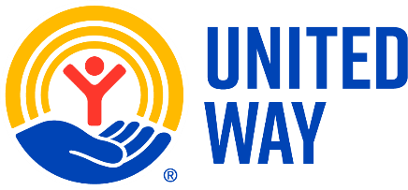**United Way of Harvey and Marion Counties**

Program Progress Report – April 1, 2025 – March 31, 2026

*Report Due: May 15, 2026 (email to director@uwhmc.org)*

Name of Funded Program:

Organization Name (if different):

Contact Person: _____________________________________ Phone: ________________

*\*\*\*NOTE: REPORT MUST BE LIMITED TO TWO PAGES\*\*\**

Communities served: Harvey____ Marion____

|  |  |
| --- | --- |
| SHARE THE DATA  (tell us about the number of clients you’ve served) |  |
| SHARE THE STORY  (tell us about how your data reflects your goal of addressing needs) |  |
| BARRIERS EXPERIENCED AND HOW THEY ARE BEING ADDRESSED |  |
| WHAT ARE THE NEXT STEPS IN ADDRESSING YOUR IDENTIFIED NEED |  |
| ACTIVITIES TO SUPPORT UWHMC ANNUAL CAMPAIGN |  |
| |  | | --- | | PLEASE SHARE EXAMPLES OF COST OF SERVICE (i.e. $50 supports match for 1 month, $500 provides meals for 1 year) | |  |